Aim:Programs on concept of Recursion
Code:

BINARY SEARCH
#include<stdio.h>
int binarysearch(int array[],int x,int low,int high)
{
if(high>=low)
{
int mid=low+(high-low)/2;
//if found at mid then return it
if(array[mid]==x)
return mid;
//search the leftbhalf
if(array[mid]>x)
return binarysearch(array,x,low,mid-1);
// search the right half
return binarysearch(array,x,mid+1,high);
}
return-1;
}
int main(void)
{
int array[]={3,4,5,6,7,8,9};
int n=sizeof(array)/sizeof(array[0]);
int x=5;
int result=binarysearch(array,x,0,n-1);
if(result==-1)
printf("not found");
else
printf("elements is found at index%d",result);
}

Output: 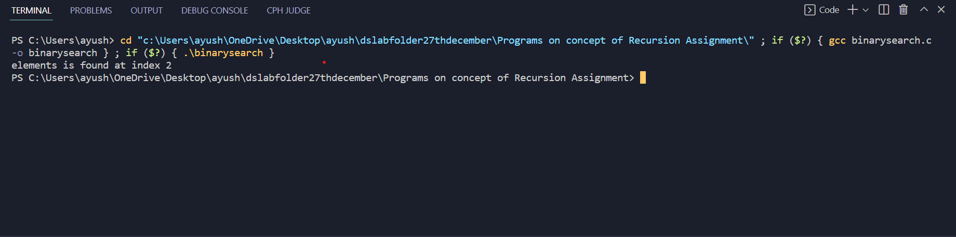

FACTORIAL

#include<stdio.h>
int fact(int);
int main()
{
int n,f;
printf("enter the number whose factorial has to be calculated:\n");
scanf("%d",&n);
f=fact(n);
printf("factorial=%d",f);
}
int fact(int n)
{
if(n==0)
{
return 1;
}
else if(n==1)
{
return 1;
}
else
{
return n*fact(n-1);
}
}

Output:
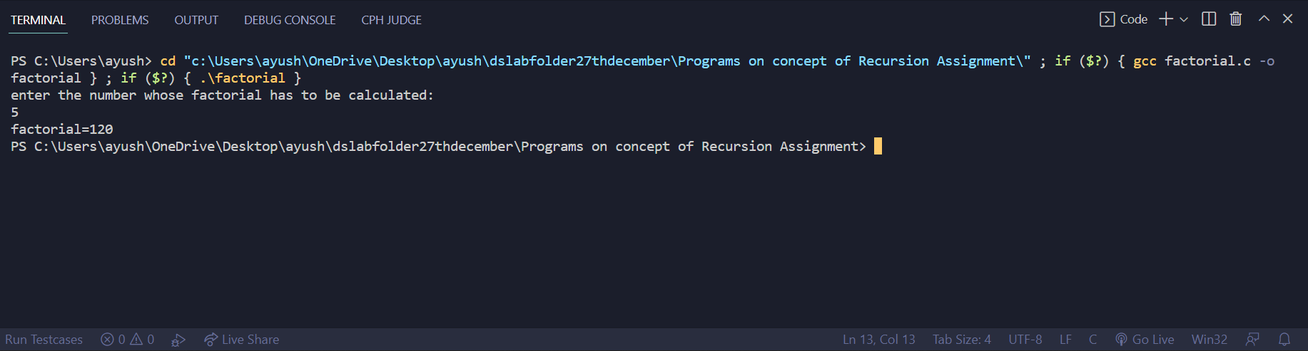

TOWER OF HANOI

#include <stdio.h> //header file

// C recursive function to solve tower of hanoi puzzle
void towerOfHanoi(int n, char from_rod, char to_rod, char aux_rod)
{
if (n == 1)
{
printf("\n Move disk 1 from rod %c to rod %c", from_rod, to_rod);
return;
}
towerOfHanoi(n-1, from_rod, aux_rod, to_rod);
printf("\n Move disk %d from rod %c to rod %c", n, from_rod, to_rod);
towerOfHanoi(n-1, aux_rod, to_rod, from_rod);
}

int main() //main function
{
int n = 4; // Number of disks
towerOfHanoi(n, 'A', 'C', 'B'); // A, B and C are names of rods
return 0;
}

Output:
